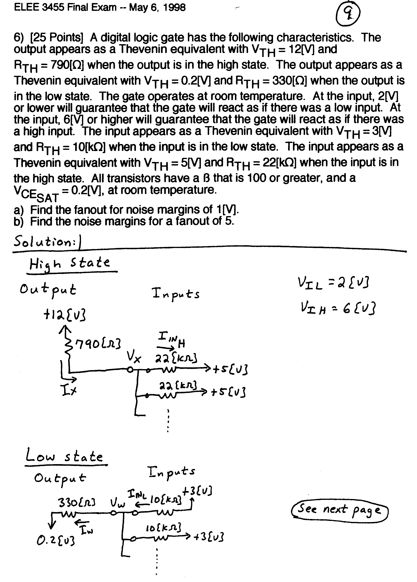
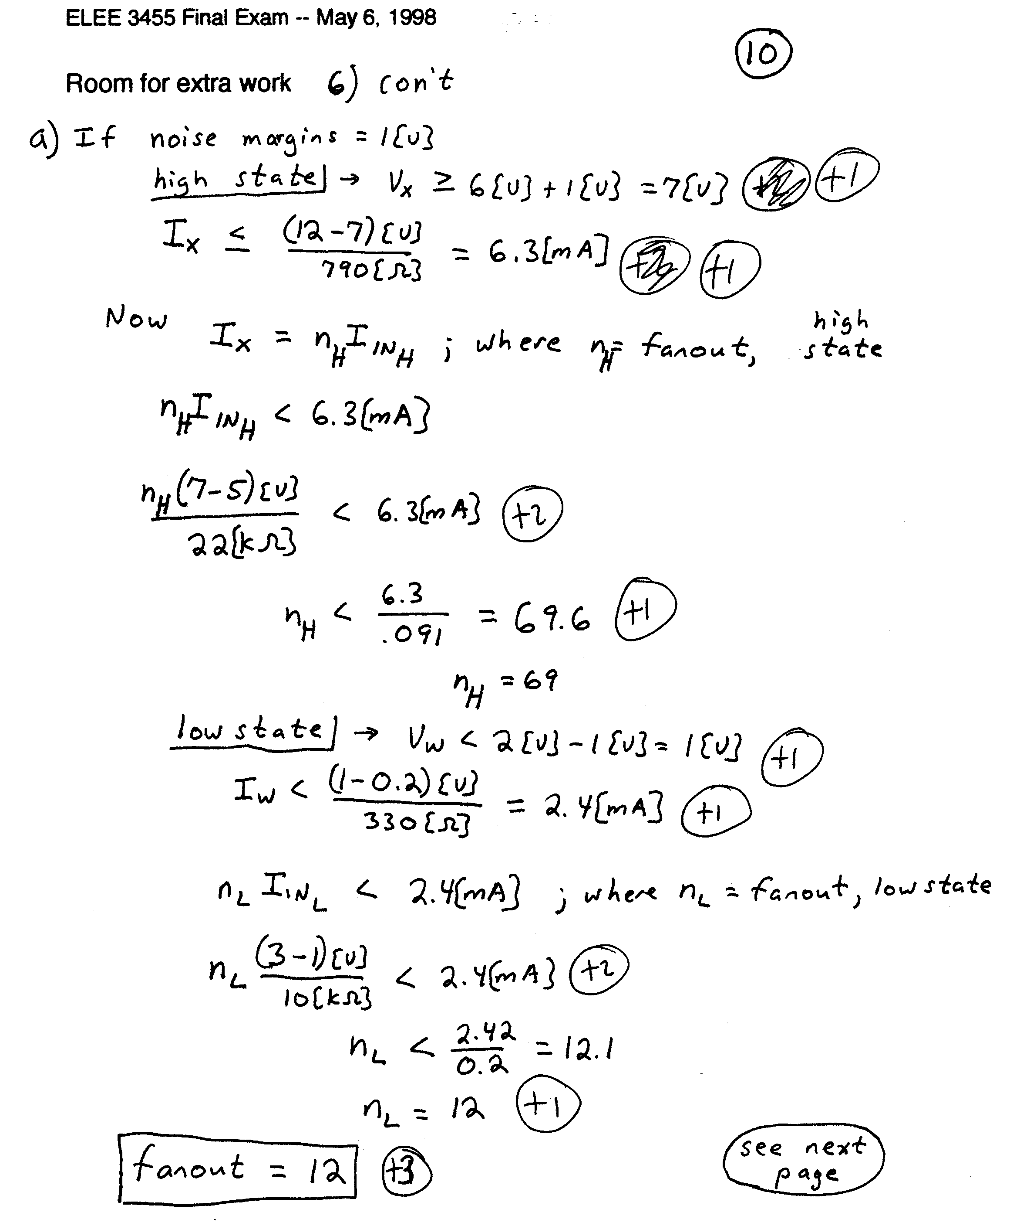

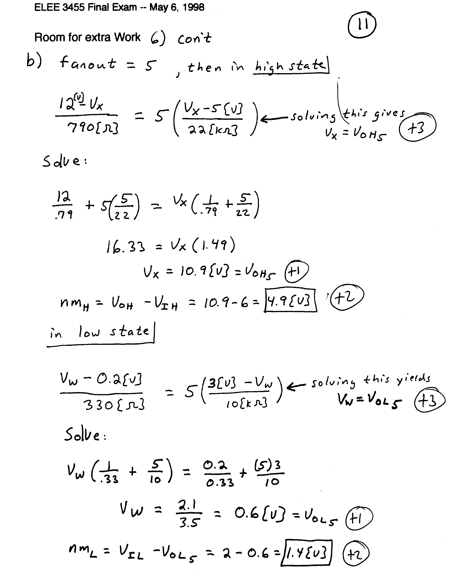

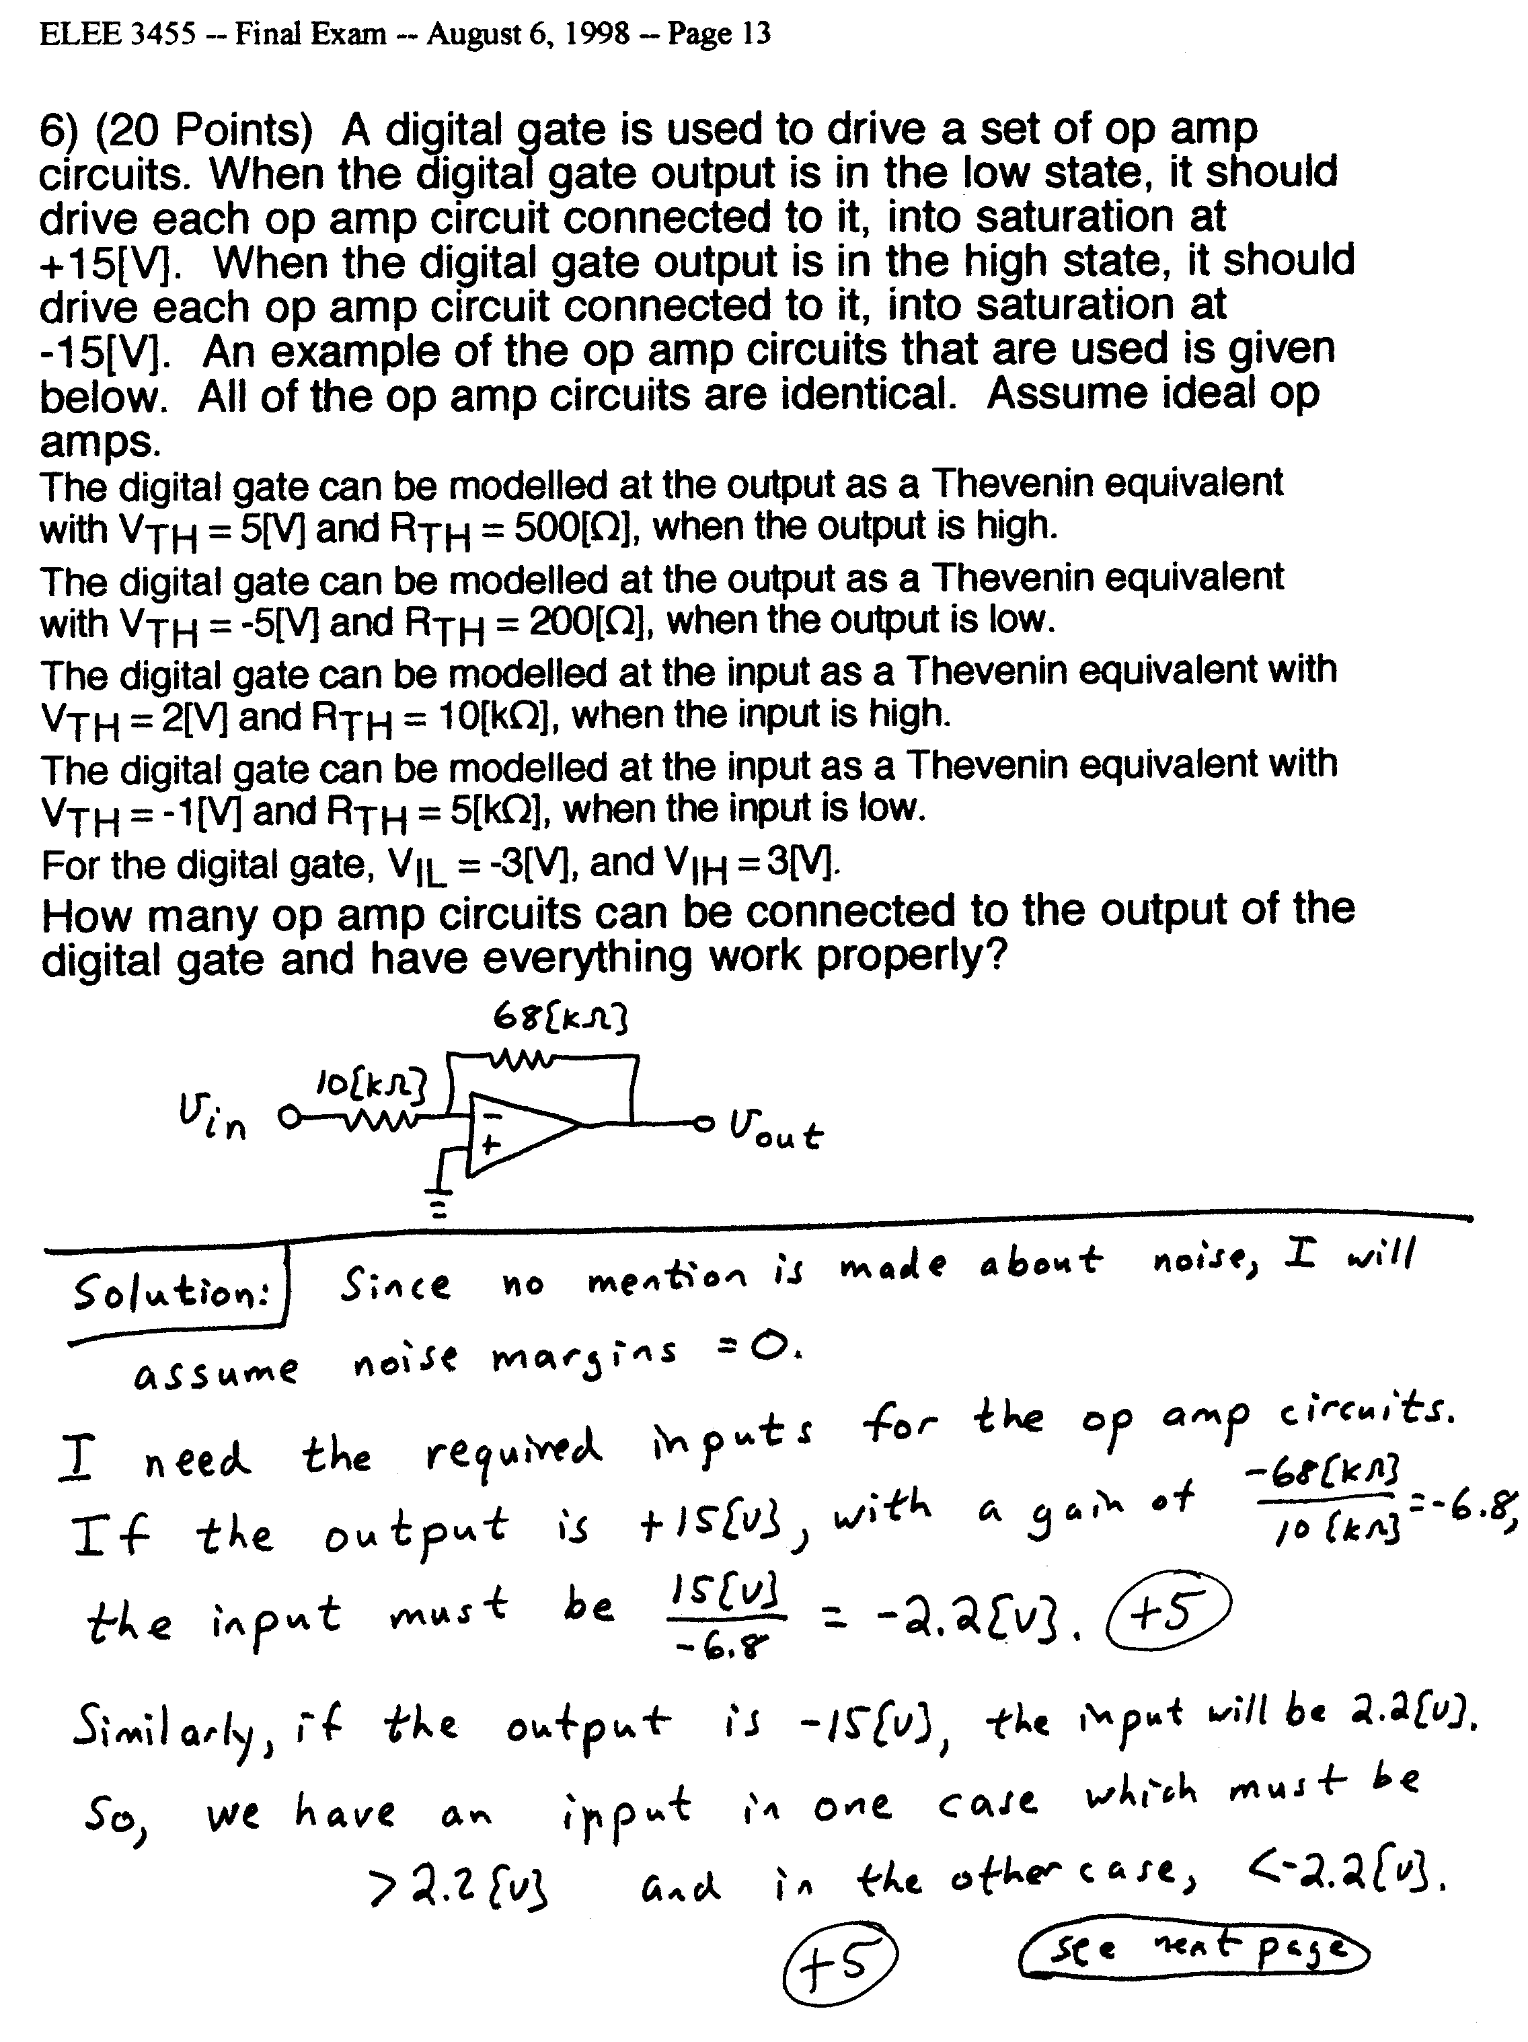
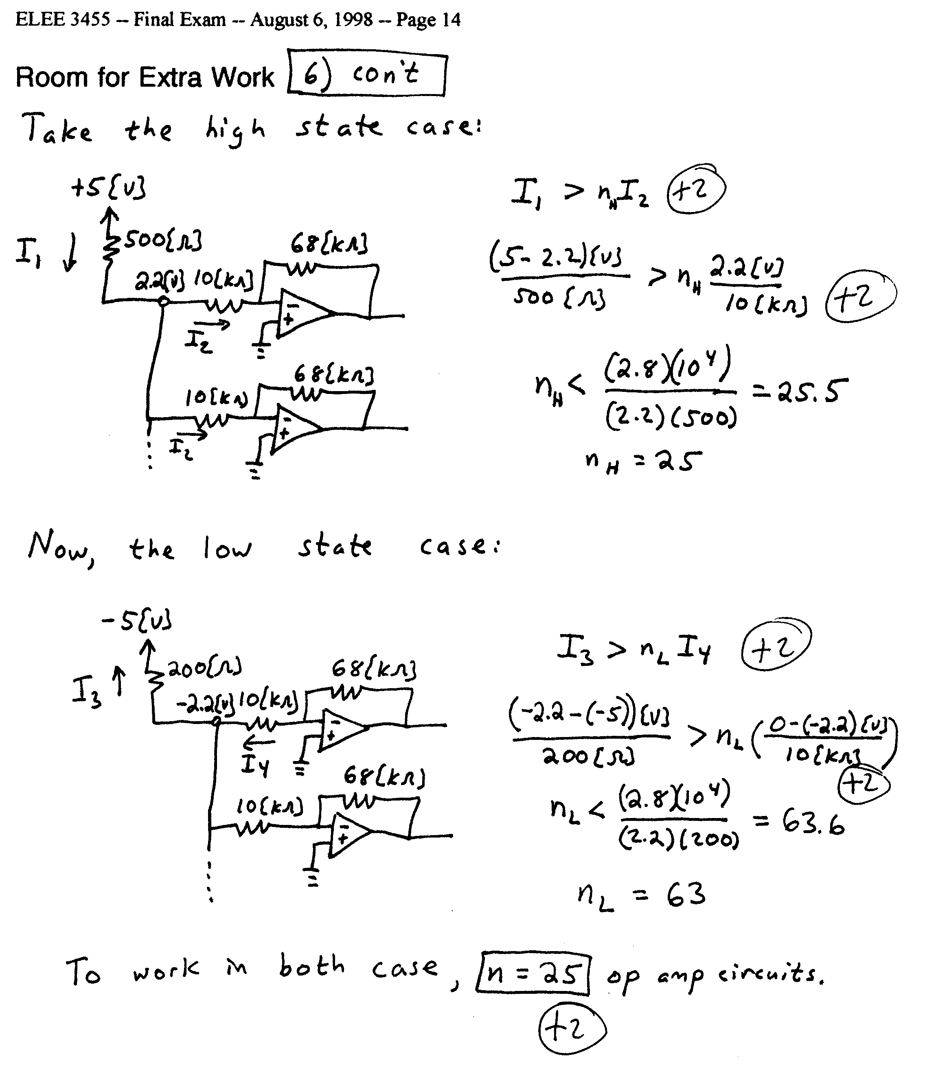
5) (18 Points) A digital logic family has the characteristics described below.
a) The output appears as the equivalent circuit in Fig. 7 when the output is in the high state. The output appears the equivalent circuit in Fig. 8 when the output is in the low state.
b) The input appears as the equivalent circuit in Fig. 9 when the input is in the high state. The input appears the equivalent circuit in Fig. 10 when the input is in the low state.
c) The gate dissipates 250[mW] when the output is in the high state, and dissipates 240[mW] when the output is in the low state.
d) Assume room temperature operation, β = 100, and V_{A} = ∞.
e) The lowest input voltage that behaves like a high input is 2[V]. The highest input voltage that behaves like a low input is -2[V].

Find the fanout for high and low noise margins of 1[V].

